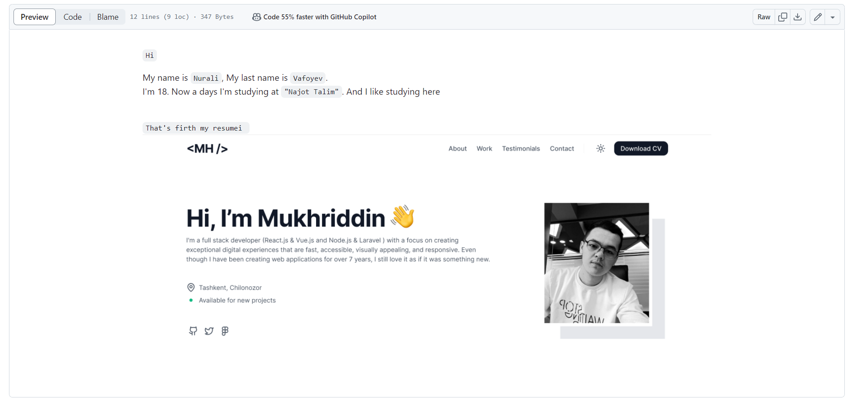

Resume (CV)

20.03.2024

Nurali Vafoyev

Frontend N9

Najot Talim

Tashkent Choponata 2

# About

Hi my full auto biography in top image  
or contact with me

t.me/vafoyev_n